

**INTERNATIONAL SCHOOL**

**PROJECT 1**

**CMU-CS 246 HIS**

**USER INTERFACE DESIGN DOCUMENT**

Version: 1.0

SOFTWARE TO SUPPORT CALCULATIONS

**Mentor:  Nguyen Dang Quang Huy**

***Team Member*:**

Hoa, Nguyen Bui Ngoc

Hung, Vo Phi

Vu ,Thai Duy

Toan, Kim Ngoc Viet

Hoang, Tran Mai Huy

Trang, Pham Minh

**Approved by Huy Nguyen Dang Quang**

**User Interface Review Panel Representative:**

Name Signature Date

**Project 1 - Mentor:**

Name Signature Date

Feb 25, 2024

**PROJECT INFORMATION**

|  |  |
| --- | --- |
| **Project Acronym** |  |
| **Project Title** | Software To Support Calculations | | |
| **Start Date** | Feb 25, 2024 | **End Date** | Jan 26, 2024 |
| **Lead Institution** | International School, Duy Tan University | | |
| **Team Member** | **Name** | **Email** | **Phone** |
| 28211103677 | Nguyen Bui Ngoc Hoa | Ngochoa.nguyenbui@gmail.com | 0838027090 |
| 28219004252 | Vo Phi Hung | Vophihung1104@gmail.com | 0342738836 |
| 28219020225 | Thai Duy Vu | Thaiduyvu0401@gmail.com | 0901125881 |
| 28218132923 | Kim Ngoc Viet Toan | Toankim633@gmail.com | 0779473633 |
| 28210206131 | Tran Mai Huy Hoang | Tranmaihuyhoang2k4.com | 0935417964 |
| 28204632177 | Pham Minh Trang | Pmtrang04@gmail.com | 0911855450 |

**PROJECT PLAN DOCUMENT**

|  |  |  |  |
| --- | --- | --- | --- |
| **Document Title** | User Interface Document | | |
| **Author(s)** | Team 6 | | |
| **Date** | Feb 22, 2024 | **File name:** | CMU-CS 246 HIS – TEAM 6 |
| **URL** |  | | |
| **Access** |  | | |

**SIGNATURE**

**Document Approvals:** The following signatures are required for approval of this document.

|  |  |  |  |
| --- | --- | --- | --- |
| **Mentor** | Huy, Nguyen Dang Quang | **Signature:** |  |
| **Date:** |  |

**TABLE OF CONTENTS**

[**I. INTRODUCTION 6**](https://docs.google.com/document/d/1l0D59sv483gd5wnQW3jct96xZbimA12J/edit#heading=h.gjdgxs)

[**1. PURPOSE 6**](https://docs.google.com/document/d/1l0D59sv483gd5wnQW3jct96xZbimA12J/edit#heading=h.30j0zll)

**[2. SCOPE 6](https://docs.google.com/document/d/1l0D59sv483gd5wnQW3jct96xZbimA12J/edit" \l "heading=h.1fob9te)**

**[II. LIST OF USER INTERFACE 7](https://docs.google.com/document/d/1l0D59sv483gd5wnQW3jct96xZbimA12J/edit" \l "heading=h.3znysh7)**

[**1. BUSINESS FUNCTION DIAGRAM: 7**](https://docs.google.com/document/d/1l0D59sv483gd5wnQW3jct96xZbimA12J/edit#heading=h.2et92p0)

[**2.**](https://docs.google.com/document/d/1l0D59sv483gd5wnQW3jct96xZbimA12J/edit#heading=h.tyjcwt) **SOFTWARE TO SUPPORT CALCULATIONS** [**8**](https://docs.google.com/document/d/1l0D59sv483gd5wnQW3jct96xZbimA12J/edit#heading=h.tyjcwt)

[**III. DESCRIBE USER INTERFACE**](https://docs.google.com/document/d/1l0D59sv483gd5wnQW3jct96xZbimA12J/edit#heading=h.3dy6vkm) **9**

[**1. INTERFACE 1**](https://docs.google.com/document/d/1l0D59sv483gd5wnQW3jct96xZbimA12J/edit#heading=h.1t3h5sf)**0**

[**2. DESCRIBE UI 1**](https://docs.google.com/document/d/1l0D59sv483gd5wnQW3jct96xZbimA12J/edit#heading=h.4d34og8)**0**

**TABLES**

[**Table 1: List of Interface**](https://docs.google.com/document/d/1l0D59sv483gd5wnQW3jct96xZbimA12J/edit#heading=h.tyjcwt)

[**Table 2: Describe User Interface Login page**](https://docs.google.com/document/d/1l0D59sv483gd5wnQW3jct96xZbimA12J/edit#heading=h.1t3h5sf)

[**Table 3: Describe User Interface Manage Accounts page**](https://docs.google.com/document/d/1l0D59sv483gd5wnQW3jct96xZbimA12J/edit#heading=h.2s8eyo1)

[**Table 4: Describe User Interface Add Account page**](https://docs.google.com/document/d/1l0D59sv483gd5wnQW3jct96xZbimA12J/edit#heading=h.17dp8vu)

[**Table 5: Describe User Update account page**](https://docs.google.com/document/d/1l0D59sv483gd5wnQW3jct96xZbimA12J/edit#heading=h.3rdcrjn)

[**Table 6: Describe User Manage employee page**](https://docs.google.com/document/d/1l0D59sv483gd5wnQW3jct96xZbimA12J/edit#heading=h.26in1rg)

1. **INTRODUCTION**

**1.** **PURPOSE**

This document describes a computer system that includes all the basic calculations and details of the implementation. The purpose of this document is as follows:

·        Support project managers to have an overview of the system and prepare project estimates

·        To describe use cases in detail. Based on this documentation, architectural analysts and designers will be able to implement the system with ease.

·        Support testers in writing acceptance tests and test plans.

**2.** **SCOPE**

* This document helps to understand better the interface of the System, detailed specification components, and function of the System.
* With this document, the development team can understand the structure and composition to create a consistent and complete system.
* Overview of the stages and modules of the software and create a complete interface.

**This document is intended for the following audiences:**

* Technical reviewers including:
* Project Managers
* System Architects
* Designers
* Implementers
* Developers
* Testers

**II. LIST OF USER INTERFACE**

1. **BUSINESS FUNCTION DIAGRAM:**

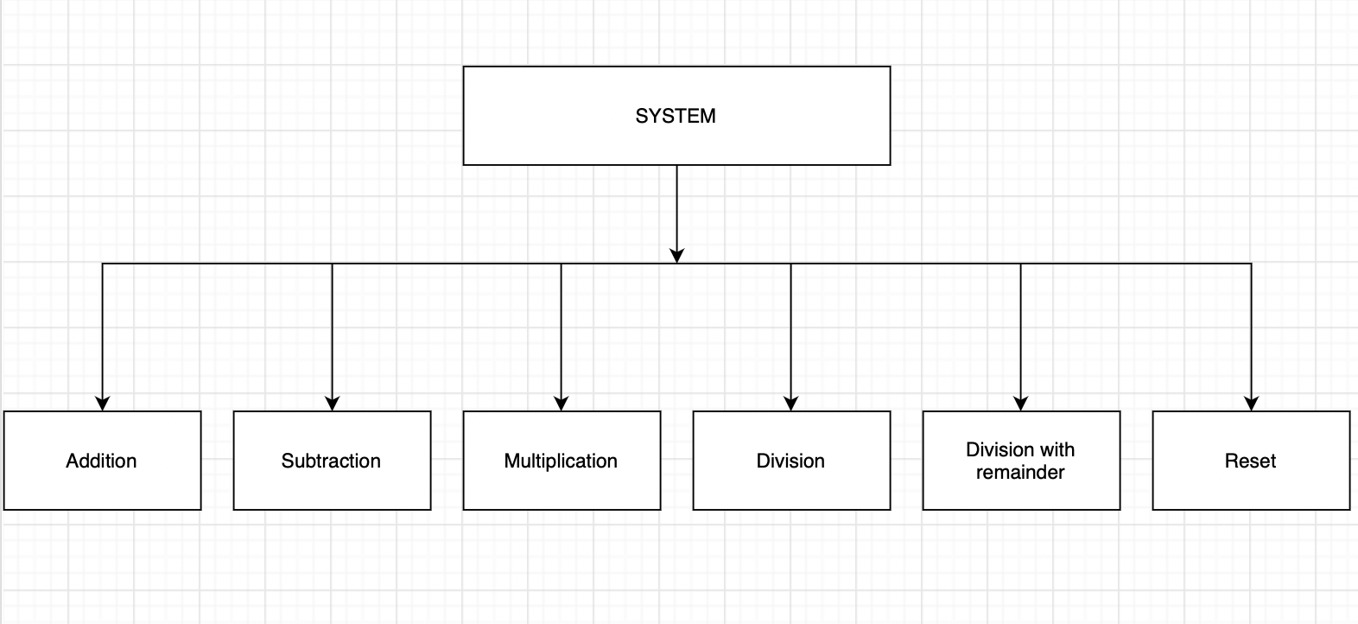

1. **SOFTWARE TO SUPPORT CALCULATIONS**

|  |  |  |
| --- | --- | --- |
| **User Interface ID** | **UI Name** | **Description** |
| UI-01 | Addiction | This use case allows the user to perform an arithmetic "+" operation. |
| UI-02 | Subtraction | This use case allows the user to perform an arithmetic "-" operation. |
| UI-03 | Multiplication | This use case allows the user to perform an arithmetic "*" operation. |
| UI-04 | Div | This use case allows the user to perform an arithmetic "/" operation. |
| UI-05 | Mod | This use case allows the user to perform an arithmetic "%" operation. |
| UI-06 | Reset | This use case allows the user to perform an reset operation. |

*Table 1: List of Interface*

**III. DESCRIBE USER INTERFACE**

1. Interface

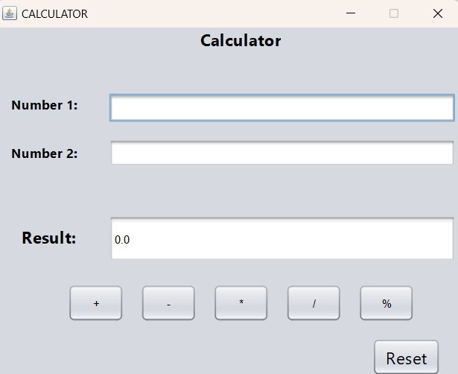

1. Describe UI

|  |  |  |  |
| --- | --- | --- | --- |
| **ID** | **Condition** | **Control Type** | **Target** |
| 1 | Press | Input text | Enter the first number |
| 2 | Press | Input text | Enter the second number |
| 3 | Press | Button | Select the “+” button |
| 4 | Press | Button | Select the “-” button |
| 5 | Press | Button | Select the “*” button |
| 6 | Press | Button | Select the “/” button |
| 7 | Press | Button | Select the “%” button |
| 8 | Press | Button | Select the “Reset” button |
| 9 | View | Text Field | Display the results |